AZURE Screenshots:

1. NSG Rules:- (Red-Team-VN NSG)

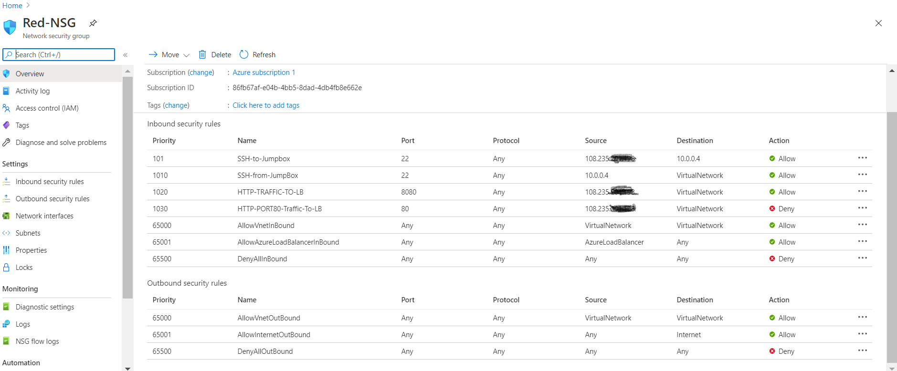

ELK Server NSG:
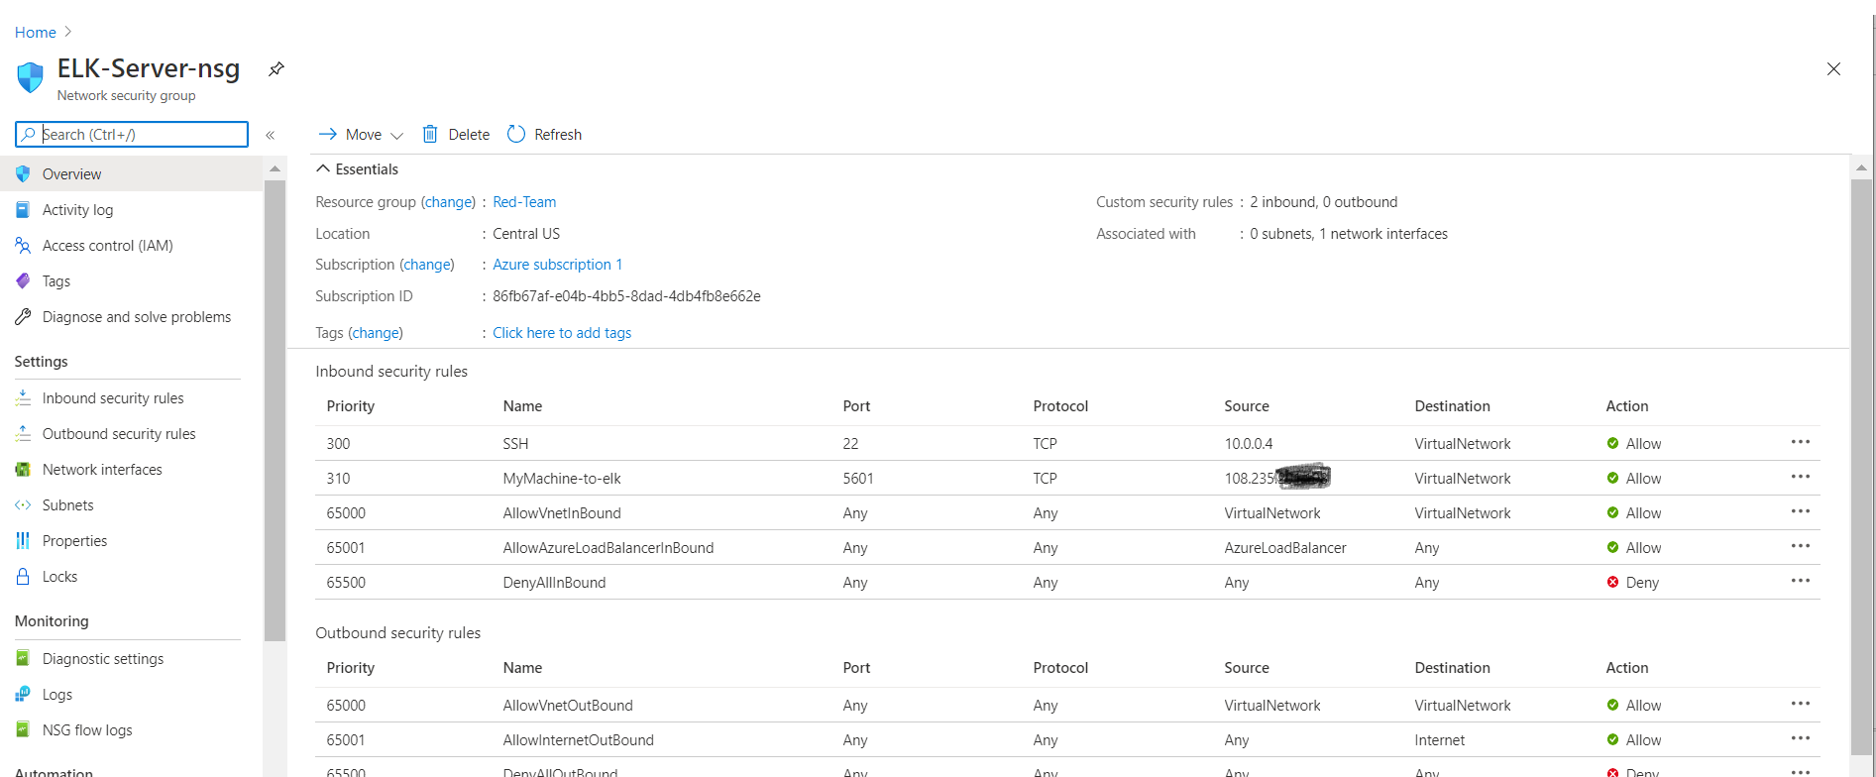

Virtual Machines Summary:-

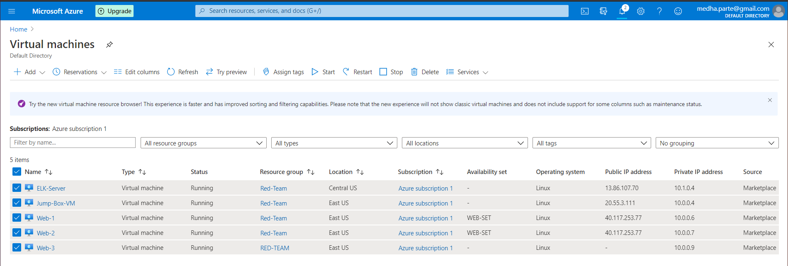

Network Topology:
Virtual Network 1 – Red-TeamVN

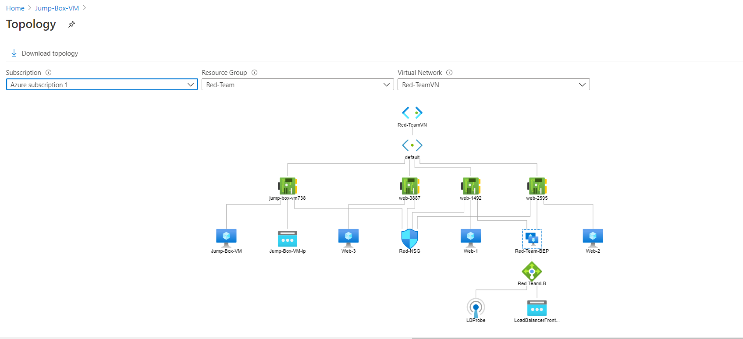

Virtual Network2 - Red-TeamVN2
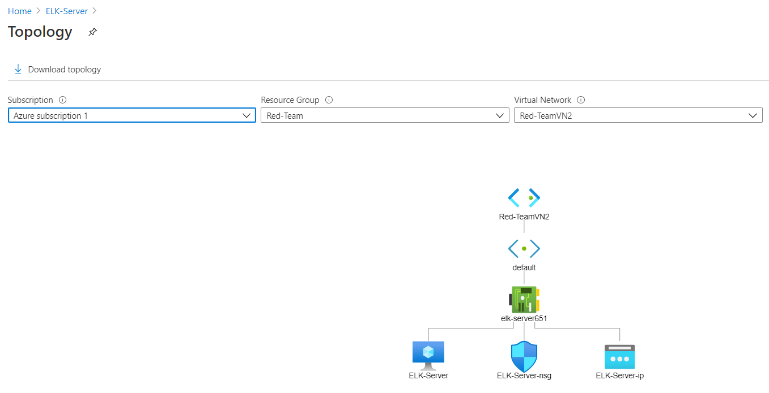

Virtual Network Peering:
